FOOD WEB NETWORK ANALYSIS AND OPTIMIZATION PROJECT

1. Understanding of Network Analysis Concepts
This project analyzes a food web network using network theory to evaluate the relationships between predators and preys.
A food web is represented as a directed, weighted graph:
- Nodes: Species or functional groups
- Edges: Feeding relationships (prey → predator)
- Weights: Energy flow strength
Types of networks and analyses used:
- Original Flow Network: Visualizes predator-prey interactions and energy flow.
- Projection Network: Shows species with shared prey or predators.
- Centrality Measures: Quantify species' importance based on connectivity.
- Community Detection: Identifies groups of species that interact densely within the group.
- Optimization: Identifying nodes critical for sustaining energy flow to improve stability in the ecosystem

2. Application of Theoretical Concepts
Theoretical models were implemented using SAS Studio with PROC NETWORK and PROC SQL. The application includes:
- Flow Summary: Using total weights to determine inflow and outflow of energy
- Closeness & Betweenness Centrality: Identifying efficient energy receivers and bridge species
- Community Detection: Clustering similar species based on interactions

Real-life implication:
In estuarine ecosystems like Chesapeake Bay, detritus and plankton are base resources, supporting a cascade of species including fish, crabs, and birds. Disruptions in these nodes could destabilize the entire system.

3. Organization and Structure
The structure has been revised to align with the rubric:
- Network Background
- Methodology & SAS Code
- Projection Network Insights
- Flow Network Analysis
- Centrality Measures
- Community Detection
- Optimization Strategies
- Real-life Ecological Mapping
- Conclusion & Recommendations
Each section transitions logically and supports the final analysis.

4. Clarity of Visual Aids
Recommendations:
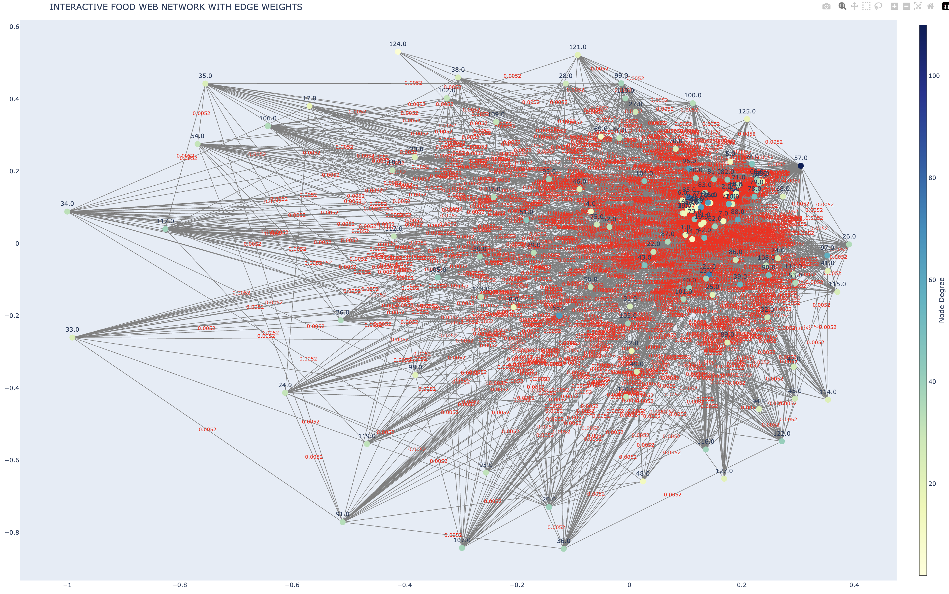
INTERACTIVE FOOD WEB NETWORK WITH EDGE WEIGHTS
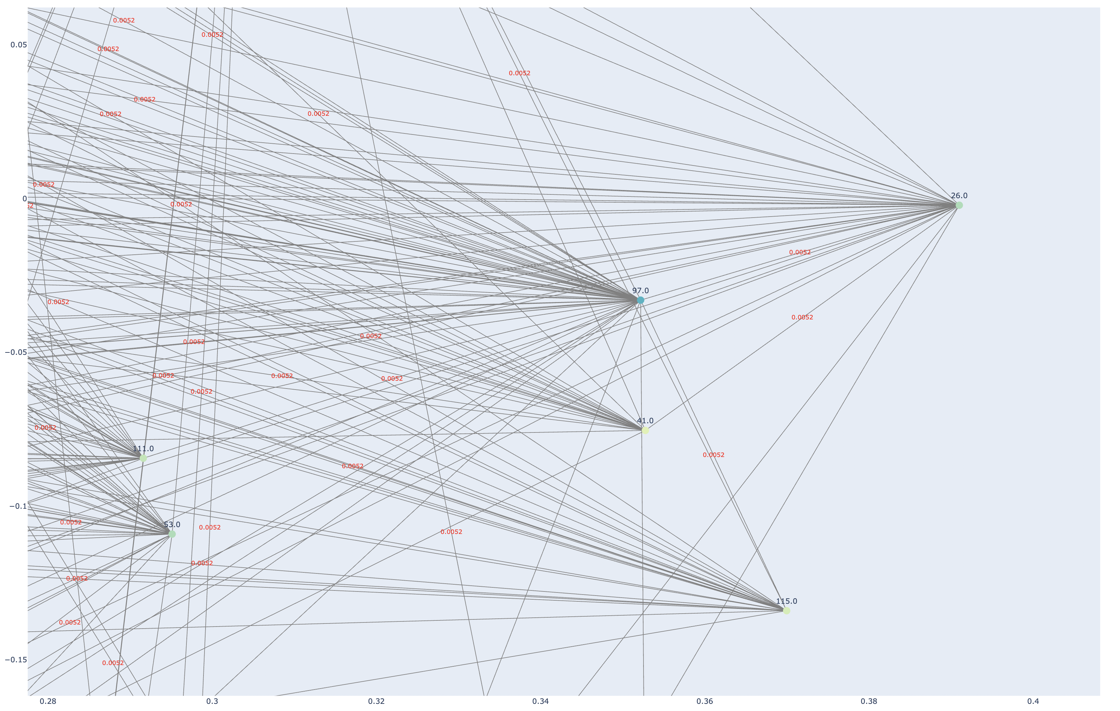
ZOOMED INTERACTIVE FOOD WEB NETWORK WITH EDGE WEIGHTS

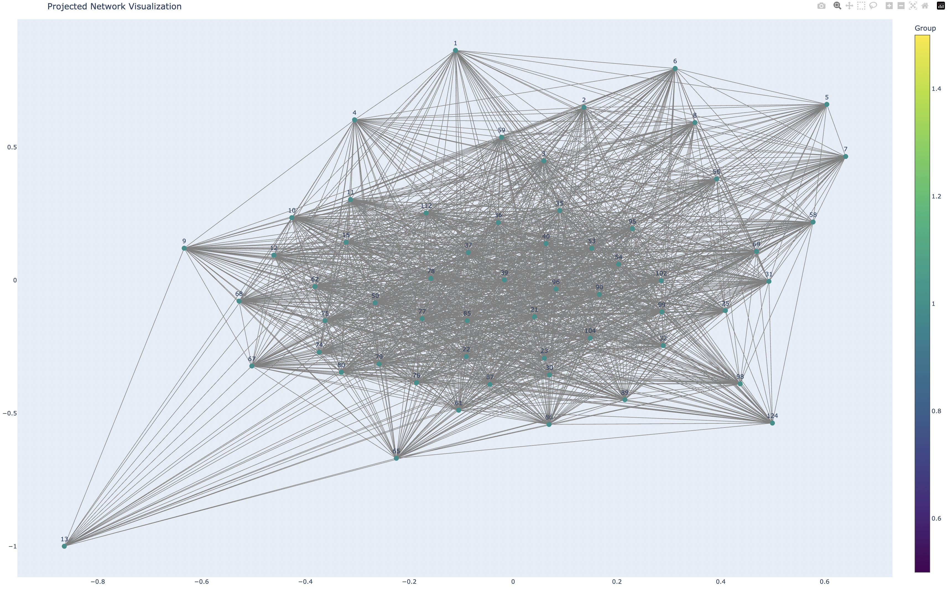
PROJECTION NETWORK VISUALIZATION

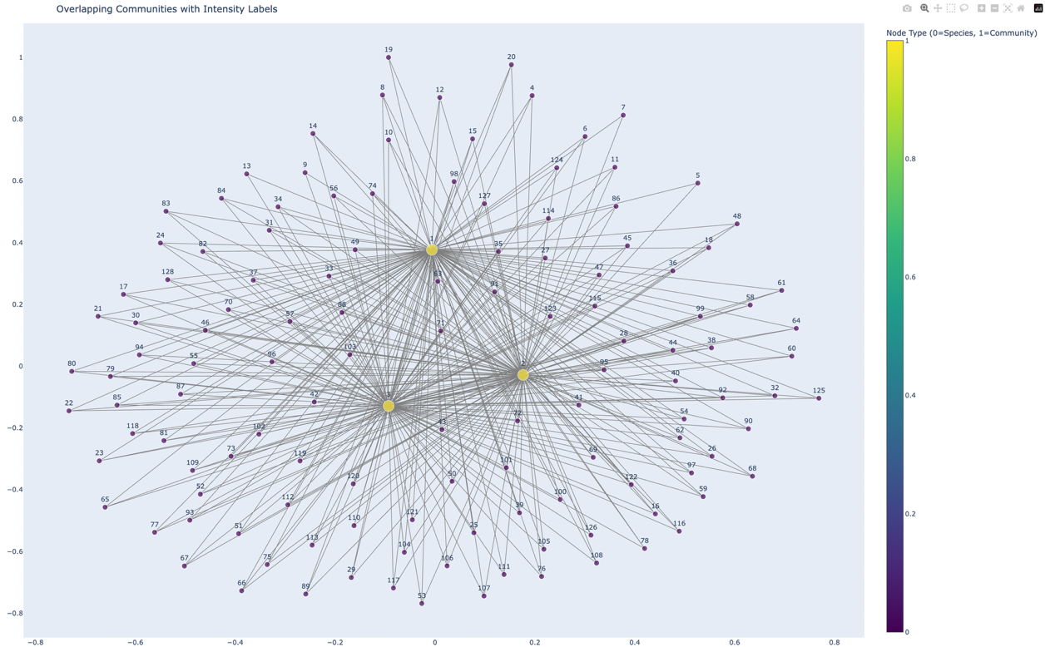
OVERLAPPING COMMUNITIES VISUALIZATION

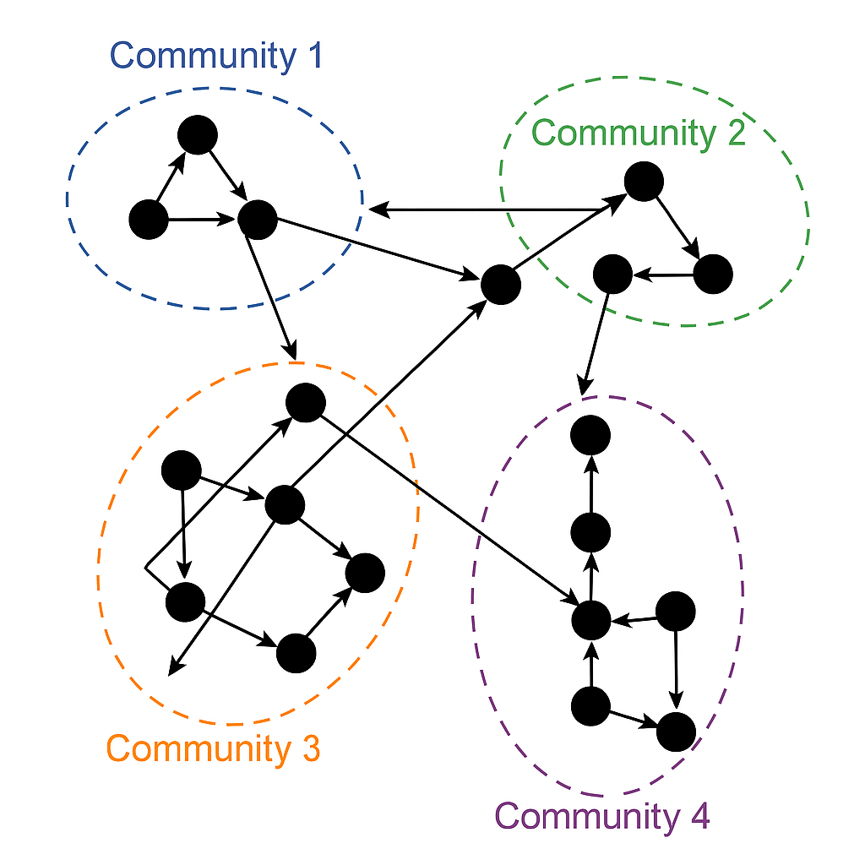
- Indicates species that play bridging roles, potentially transferring energy or interactions across compartments (omnivores).
- Identifies clusters or compartments where most species interact within their own group.

Example: Energy Flow Summary
Node ID | Total Energy Inflow | Total Energy Outflow | Role
57 | 725.05 | 0.00 | Resource provider
128 | 585.52 | 585.52 | Mid-level consumer
1 | 0.00 | 738.54 | Apex predator
Visualizations can further include network graphs colored by centrality or role.
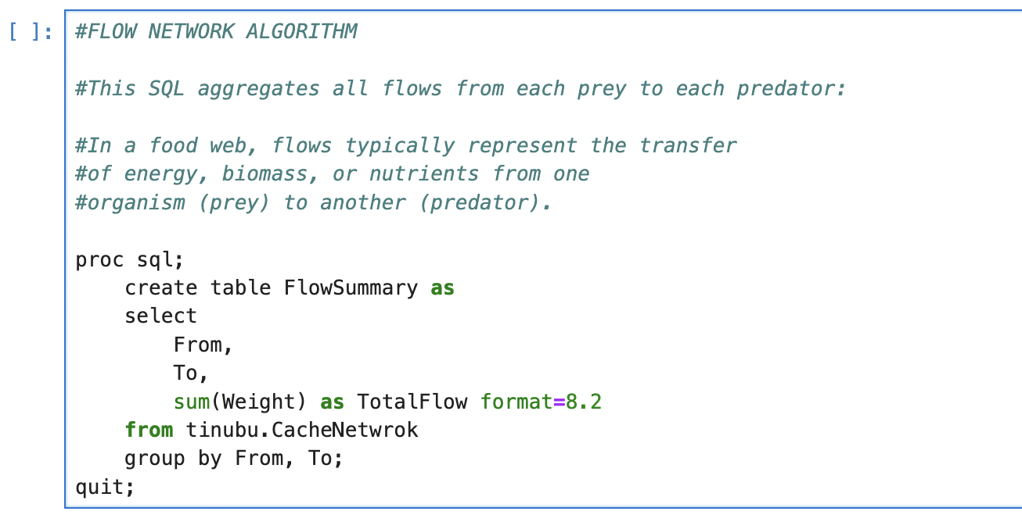

Example: Top 5 Prey Nodes (Projection Network)
Node ID | Number of Predators | Interpretation
104 | 55 | Likely small herbivore
112 | 54 | Likely plankton species
102 | 53 | Insect or grass
99 | 52 | Insect or plant species
96 | 50 | Key prey hub
These are likely keystone prey supporting many predators. For instance, Node 112 might represent phytoplankton in aquatic systems.

Example: Top 5 Predators (Projection Network - Apex Consumers)
Node ID | Number of Preys | Interpretation
3 | 50 | Likely top predator (e.g., shark, eagle)
2 | 49 | Generalist predator (e.g., human, large fish)
10 | 48 | Omnivorous or dominant carnivore
11 | 47 | Opportunistic predator
12 | 46 | Wide-diet predator
These nodes represent top predators in the ecosystem. They rely on a broad range of prey and can affect multiple trophic levels
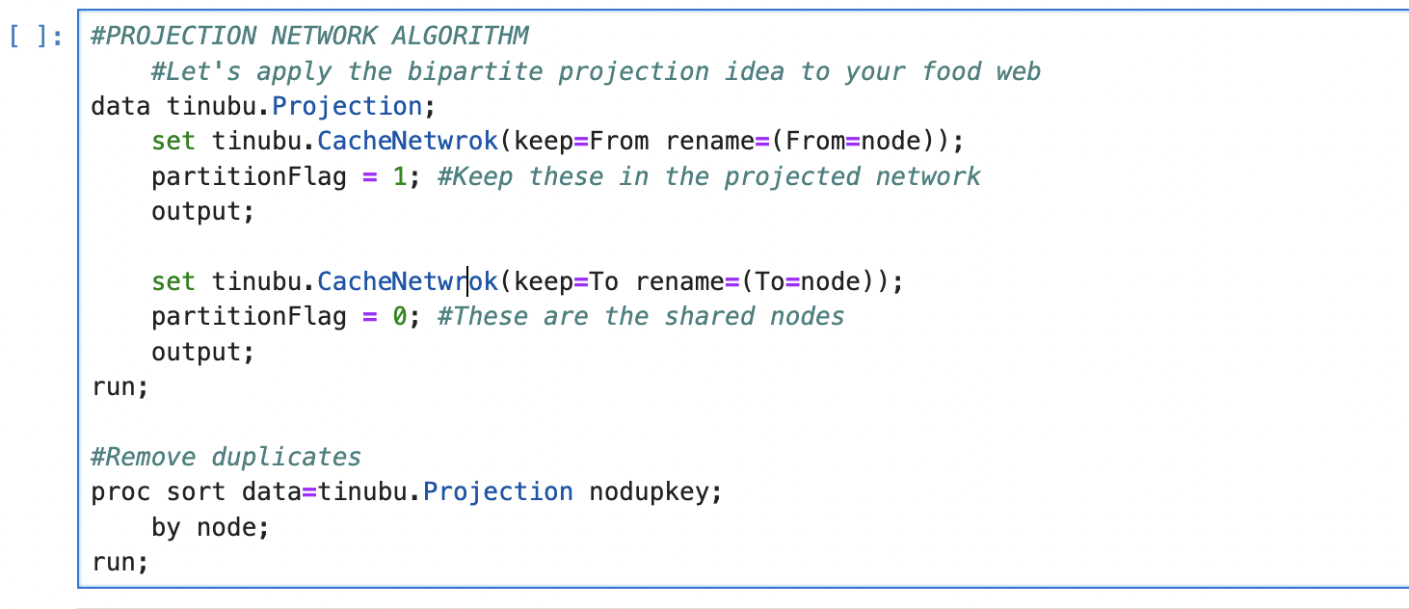 | 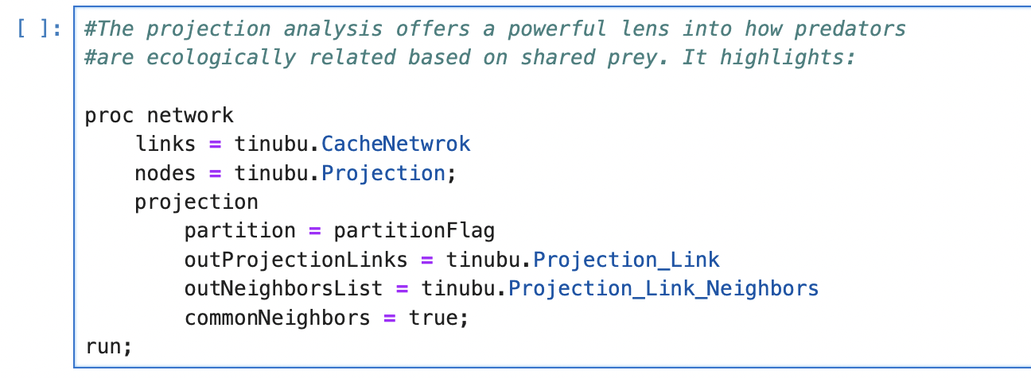

5. Team Collaboration and Contributions
Each team member contributed to different technical and analytical sections:
- Jepchumba, Maurine (2517750): Document structuring and editing
- Okechukwu Eze (2504607): SAS implementation and visualization
- Kipngetich, Theophilus (2444934): SAS setup and code support
- Eniola Adeola Salako (2427111): Document structuring and analytics

6. Depth of Analysis and Insights
Key insights from multiple network layers include (Flow Summary):
- Node 57: Highest energy provider (likely phytoplankton or detritus)
- Node 1: Top energy consumer (apex predator like a shark or lion)
- Node 128: High betweenness and equal inflow/outflow — likely a small fish or mid-level species

Centrality Summary
Node | Betweenness | Closeness | Ecological Role
128 | 0.5528 | High | Mid-level connector
10 | 0.3080 | High | Predator
57 | Low | High | Prey/energy source
- Species with high closeness can quickly influence others in the network (e.g., spread changes through the food chain fast).
- Species with low closeness may be isolated
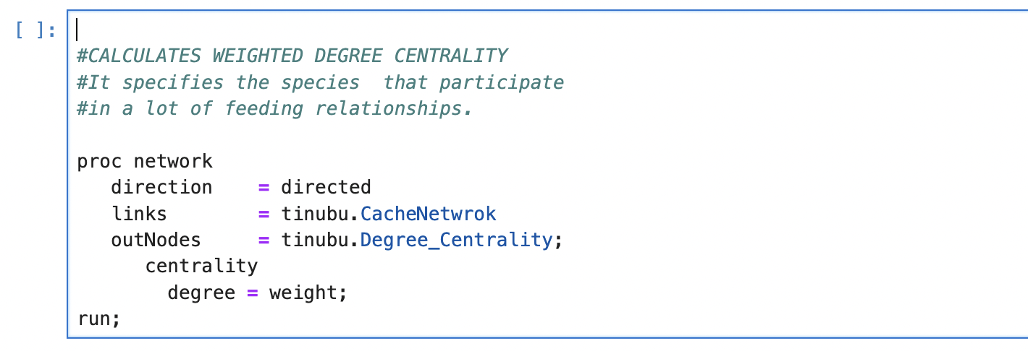
Top Species (by betweenness):
Node | Betweenness Centrality
57 | 0.71804 ← ⭐️ Highest
18 | 0.39520
128 | 0.55281
1 | 0.32558
10 | 0.30796
12 | 0.07599

Interpretation:
- Node 57 is the most ecologically central species in your food web.
- It likely connects multiple prey and predator paths

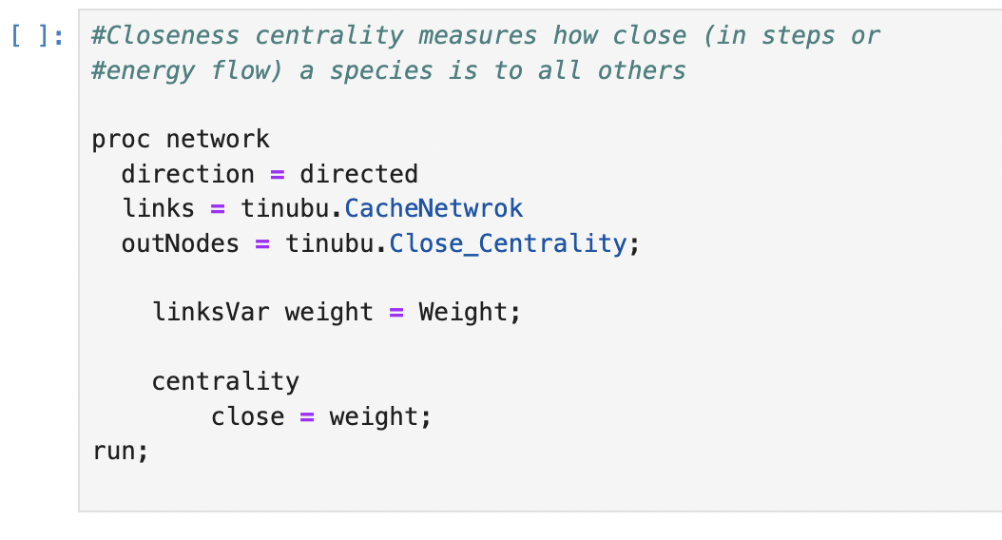 | 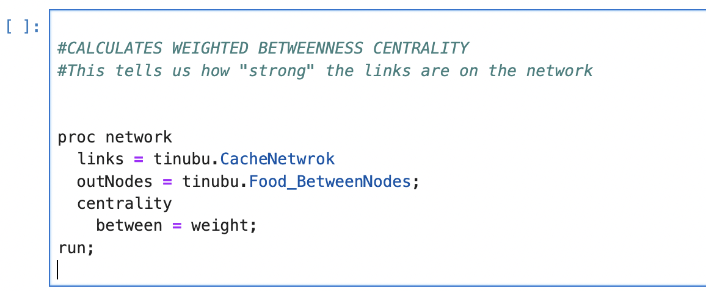

Optimization Strategies for the Ecosystem
- Preserve central preys: Species like Detritus and Phytoplankton are vital for network stability.
- Increase prey redundancy: Encourage biodiversity to prevent over-dependence on a single prey.
- Monitor high-betweenness predators: Their removal may disconnect sub-networks.
- Introduce bridging species: To reconnect isolated subnetworks and improve resilience.
- Flow-based conservation planning: Prioritize species that support multiple food paths.

Community Interactions
Shows interactions between communities, akin to food flows across compartments.
From Community | To Community | Link Weight
1 | 4 | 325.19
2 | 4 | 302.97
1 | 2 | 236.35
Interpretation:
- Community 1 interacts heavily with 2, 3, and 4, indicating high connectivity.
- link_weight could represent number or strength of predator-prey links.
- Communities with lower link weights between them are more autonomous — these are your ecological compartments
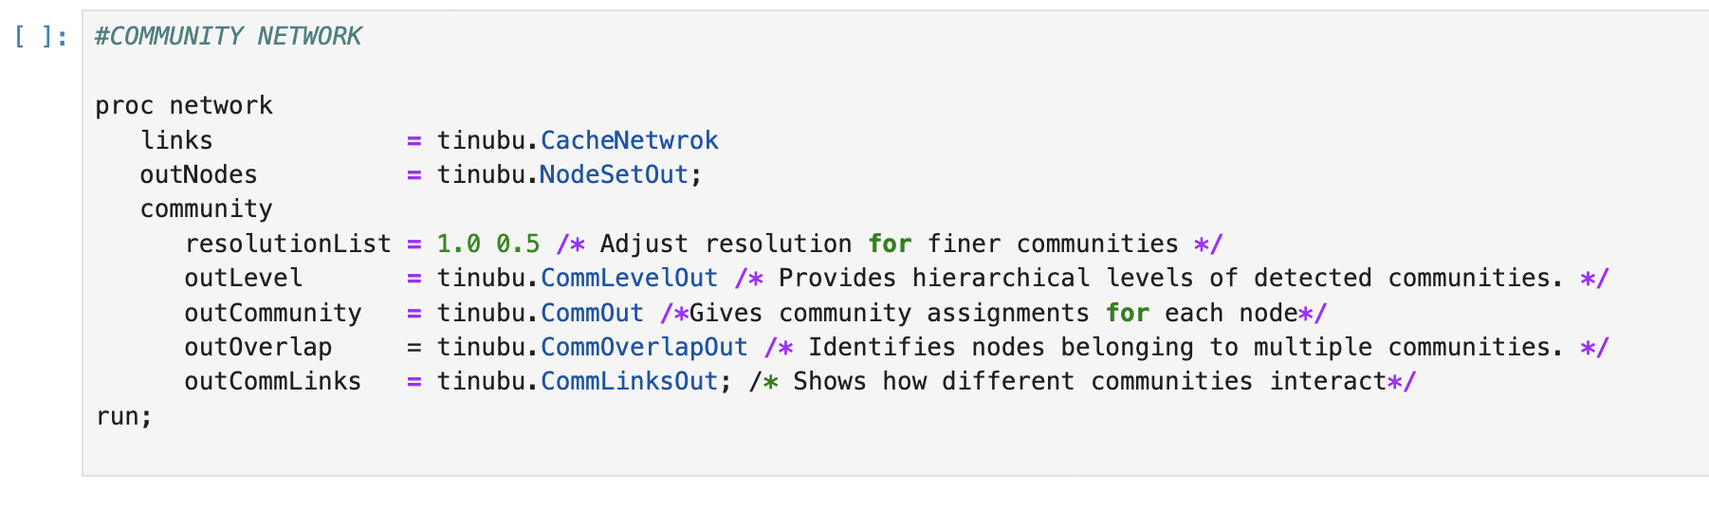

Conclusion
This network analysis demonstrates how numerical models can reveal ecological vulnerabilities and opportunities. By protecting hub species, monitoring high-flow predators, and preserving community integrity, we can build a more stable and resilient ecosystem.

